AMH & URHP Combined Conference and AGMs
June 18th and 19th 2011

Venue: Ryton Gardens, Coventry, Warwickshire, CV8 3LG

Programme

Saturday 18th June

9.15-10.00am Registration and Welcoming Refreshments
10.00-12noon Spagyric Essences, Holistic Remedies for Body, Mind and Soul
Speaker: Dr Elisabeth Bindschaedler
12.00-2.00pm Lunch followed by an Opportunity to Explore the Organic Gardens
2.00-3.20pm The Use of Essential Oils in Herbal Medicine
Speaker: Rosalind Blackwell
3.20-3.40 Tea Break
3.40-5.00pm The Use of Essential Oils in Herbal Medicine (contd)

Sunday 19th June

9.10-10.40am Allergies and Intolerances - Diagnosis and Treatment
Speaker: Christine Herbert
10.40-11.00 Tea Break
11.00-12.30pm Getting Rid of Your Rubbish! - Practical Cleansing for Everyone
Speaker: Julia Russell
12.30-2.00pm Lunch
2.00-5.00pm AGMs (with Refreshments provided at 3.30pm)

--------------------------------------------------------------------------------------------------------

Booking Form

I would like to attend: (Please indicate)

Saturday 18th June O Sunday 19th June O

Saturday, including vegan lunch and refreshments is £55.00
Sunday, including vegan lunch and refreshments is £40.00

Name: ___________________________ Member of: AMH URHP (please circle)

Address: _____________________________________________________________

Telephone: ___________________ E-mail: ________________________________

Please return form together with payment to: Anton Bennett, 18 Victoria Street, Settle, BD24 9HD by 20th May 2011.
Please make cheques payable to: Association of Master Herbalists

How to Get to Ryton Gardens – copied from Ryton Gardens Website.

How to get to Ryton Gardens by car:
Ryton Gardens
Coventry
Warwickshire
CV8 3LG
Ryton Gardens is located five miles south east of Coventry off the A45. There are white on brown tourist signs to watch for as you approach our entrance. Please note that despite our postal address we are not actually in the village of Ryton on Dunsmore, we are on the outskirts of the village of Wolston.
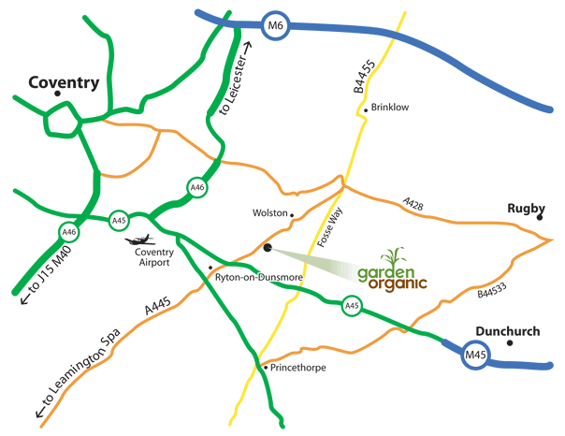

From the North: Exit the M1 at junction 21 and take the M69 all the way to its end where you pick up the A46. Continue along the A46 until you reach a large roundabout (Tollbar End roundabout) with Northampton/London A45 signposted to the left. Take this left turning onto the A45. Continue along the A45 - a good landmark to watch for is the big Peugeot works which will be on your right.
After a couple of miles you will pass a Ryton on Dunsmore sign on the A45 itself. You go down a dip and then, as you come up again, get into the lefthand lane on the approach to a large roundabout. You will see Ryton Gardens signposted to the left. This is also the turning for the village of Wolston. Take the first exit off the roundabout and continue along the road for about 500 metres to our entrance on your right. There is a spacious car park and parking is free of charge.
If you are coming along the M6, exit at junction 2 (taking the A46) and then proceed as above.

From the South: Exit the M1 at junction 17 and take the M45 for Birmingham. The M45 becomes the A45. Follow the A45 for about 3 miles. Go straight across at the Fosse Way (B4455) roundabout and about 1 mile further on you come to a large roundabout. Get into the righthand lane and turn right off the A45 for the village of Wolston. The gardens are signposted at this roundabout. Follow the Wolston road for 500 metres and then find us on the right hand side with a big free car park.

Getting to Ryton Gardens by Public Transport:
The nearest rail stations to Ryton Gardens are Coventry and Rugby.

From Coventry:
The Stage Coach, Midland Red bus service number 86 journeys between Coventry and Rugby and stops in the village of Wolston, which is about a one mile walk from Ryton Gardens. Unfortunately, there is no direct bus service to the gardens.
Buses stop in the centre of Wolston but, to take you a little closer to the gardens, get off at the next stop, in the Bennetts Court housing estate. Not all the buses go to this stop so ask the driver. Take a few steps back to the main road then head out of the village towards the A45. Ryton Gardens is on your left.
The 86 bus leaves from Stand B4 outside the Trinity Church, Trinity Street (next to Cathedral Lanes shopping precinct and the Lady Godiva statue). Service is Monday-Saturday on the hour. Restricted service operates on Sundays.
The journey takes about 25 minutes and cost approx. £3.50 return.
You can check the timetable by calling 01788 535555 01788 535555 during weekdays.
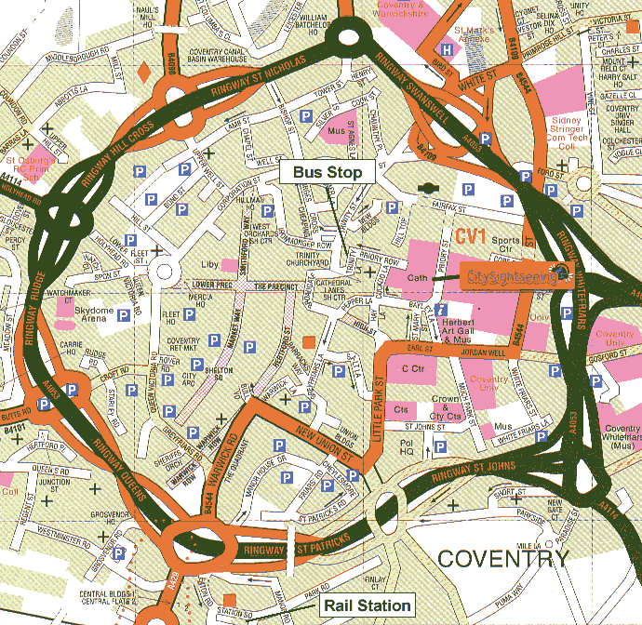
Map reproduced by kind permission of City Sightseeing

From Rugby:
The 86 bus leaves from North Street (outside 'New Look' department store), which is about a ten minute walk from the railway station (see map below).
Leave the railway station on the south side, via the ramp from Platform 1. Turn RIGHT out of the station along Station Terrace. Follow Station Terrace around the left hand bend and then walk RIGHT down Albert Street. Bear right onto Regent Street. At the end of Regent Street, turn LEFT onto Park Road then bear LEFT onto North street. The No 86 bus stop is on your right outside the Littlewoods department store.
There is an hourly service between 9am and 5pm on weekdays. A restricted service operates on Sundays.
The journey takes about 25 minutes and cost approx. £3.50 return.
You can check the timetable by calling 01788 535555, 01788 535555, or Stagecoach Midland Red on 01604 620077, 01604 620077, during weekdays.
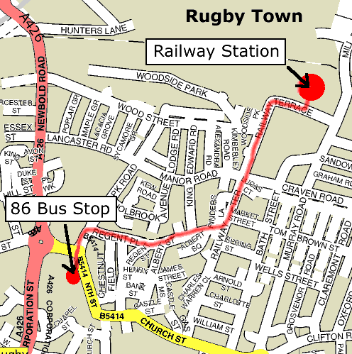

Cycling to Ryton Gardens
from Rugby or Coventry

If you are travelling with your bicycle to Ryton Gardens from outside the area and need to travel by train for part of your journey it is recommended that you get off at Rugby. The cycle trip from Rugby is more pleasant and easier to follow than cycling from Coventry.

From Rugby: (Approx. 8 miles along quiet lanes)
- Leave the railway station on the south side, via the ramp from Platform 1.
- Turn RIGHT out of the station along Station Terrace. Follow the road around to the left then take the first RIGHT turn along Wood Street.
- At the end of Wood Street (large junction, railway bridge to your right, sign saying 'Alstom' opposite) turn RIGHT along the A426 and go under the railway bridge.
- Take the first LEFT off the roundabout, along the B4112 through Newbold on Avon.
- Follow the road up the hill and around a sharp Right Hand Bend. Then turn LEFT, signed to Little Lawford.
- Continue on this lane for 2 miles following signs to King's Newnham.
If you have a copy of OS Landranger map no. 140, you may be tempted to take a detour at Little Lawford, through Long Lawford and over the Lawford Heath to Wolston. This is a nice route but, be warned, you need to cross a ford which is more than knee-deep and about 30 yards wide! (Nice for a paddle)
- After King's Newnham, continue on the same lane past a left hand turn for Church Lawford and past the remains of a church tower on your left.
- At the end of the lane, turn LEFT onto the Fosse Way (B4455), into Bretford past the Queen's Head pub. Follow the road around to the left (where it briefly becomes the A428). Go over the river bridge at the traffic lights and then take the first RIGHT turn to rejoin the Fosse Way.
- After the railway bridge turn RIGHT where it is signposted to Wolston. Continue on this lane for 2 miles, through the village of Wolston.
- Ryton Gardens is on the LEFT at the bottom of a hill.

From Coventry:
Cycling from Coventry you have the choice of a short but scarey route along the A45 (about 6-7 miles) or more scenic routes using quieter roads and lanes (9-10 miles).
The quickest but least pleasant route to Ryton Gardens. The A45 route is the simplest to follow but involves cycling along mainly fast stretches of busy dual carriageway.
- Leave the city of Coventry heading south along the A429. See map above, the A429 is the Kenilworth Road which begins as the Warwick Road which runs close to the rail station (there is pedestrian access from the rail station onto the A429 by leaving the front of the station and following the pavement past the Bicycle Association offices, around to the left and joining the road heading left away from the city centre and over the railway line). Bear left as the road forks at the large Memorial Park.
- Continue along the road with the Park to your right until you reach a roundabout with the A45. Turn LEFT at this roundabout and follow the A45 for about 5 miles. There is a cycle path alongside certain stretches of the road, but it is not continuous and the surface is poor in places.
- Take great care at the large Tollbar roundabout, where the A45 meets the A46 and the road divides into lanes for access to the A46 and M69. If you wish you can take the pedestrian crossing over the first two turn-offs to avoid cycling on the roundabout at all. Otherwise, get in lane for A45 (London) and go straight across at the roundabout.
Shortly after this roundabout, look out for a cycle lane (marked with red tarmac) leading off to your left immediately after the petrol station. You can take an alternative route here if you wish, which will take you along a quiet back lane to the village of Wolston. You will pass the Brandon Marsh Nature Reserve and then the Royal Oak pub on your left as you enter Brandon village. Turn RIGHT here, under the railway bridge and over a humpback river bridge into Wolston village. Turn RIGHT at the T-junction in Wolston and stay on this road for about 1 mile where you will see the entrance to Ryton Gardens on your left. This detour will add about 1 mile to your journey (but probably save a few grey hairs!).
If you decide to continue along the A45 rather than take the alternative route along Brandon Lane, you will pass the Peugeot car plant on your right as you approach the village of Ryton on Dunsmore. Shortly after Ryton on Dunsmore you will see a brown tourist information sign indicating that Ryton Gardens is a LEFT turn off the roundabout, towards the village of Wolston. Take this turn and the entrance to Ryton Gardens is on your RIGHT after about 800 yards. . Enjoy a strong cup of organic coffee to settle your nerves!
For a more pleasant, scenic route avoiding both the A45 and the A429. (9-10 miles)
- Leave the rail station by wheeling your bike along platform 1, past the cafeteria, away from the exit and the ticket office. Don't go up the steps to the road. Instead, follow the path under the road and onto the Central Six shopping centre car park. Your train tickets will be checked as you leave platform 1 - so don't discard them as you leave the train.
- See that light grey pedestrian suspension bridge over the car park? Make your way to the end near the large sports shop. You are now on a designated cycle route out of the city centre - cycle over the bridge (over the railway) and along the path between the school grounds on your left and the park on your right.
- At the end of the path, head down Dalton Road - immediately OPPOSITE. Follow it around to the right and then turn LEFT down Belvedere Road.
- At the end, turn RIGHT onto Earlsdon Avenue South and then first LEFT onto Warwick Avenue.
- At the end of Warwick Avenue continue STRAIGHT ACROSS Beechwood Avenue onto Stoneleigh Avenue.
- At the end of Stoneleigh Avenue turn RIGHT onto the A429 Kenilworth Road (or follow the cycle path on the side you are on, cross at the push-button crossing and wheel you bike to the next left turn) and take the next LEFT turn down Coat of Arms Bridge Road (if you come to the A45 junction you have gone too far).
- In about 200 yards turn RIGHT into Green Lane. Green Lane joins the A45 but there is a pedestrian subway underneath. Go through this subway - dismount and watch out for glass - and then turn RIGHT at the top of subway slope, walk 10 yards along the pavement to rejoin Green Lane heading away from the A45.
- Continue along Green Lane until it ends at a staggered crossroads. Turn RIGHT along St Martins Road (B4113), under the A46, and stay on this road until you enter the pretty village of Stoneleigh.
- Follow the road left over a river bridge, and then immediately turn off LEFT and up the hill. Continue on this road, past the golf course on your right, until you reach a left turn signposted to Bubbenhall immediately opposite a large arched entrance gate. Turn LEFT here and continue for 1.5 miles on this lane, through Bubbenhall, until it joins the Leamington Road (A445).
- Turn LEFT onto the A445. The A445 can be quite busy at rush hour times, but is usually fairly quiet otherwise. Stay on the A445 past Ryton Pools (lakes) and straight across 1 roundabout (where the A445 and A453-Banbury Road cross).
- You then have two options:
  - If you continue along the A445 you will come to a large roundabout where the A445 is crossed by the A45. Go straight across at the roundabout, following the brown tourist 'Ryton Gardens' sign. This roundabout gets busy at rush-hour times.
  - Alternatively, to avoid having to cross the A45, take the next turn LEFT (past the Ryton Nurseries garden centre - lots of sheds, pigs and small goats!) through the village of Ryton on Dunsmore on a 20mph speed-restricted road. Where the road meets the A45 there is a pedestrian subway (with bike-friendly slopes) which takes you under the A45. When you emerge out of the subway, via the slope, turn to your RIGHT and follow the wide pavement as it follows the A45 and turns left towards Wolston.
- The entrance to Ryton Gardens is on your RIGHT after about 800 yards.

Note from the Webmaster: "I have been cycling the scenic route between Coventry and Ryton for many years now and can recommend it if you need to travel from Coventry. I've come down the A45 once in that time - once was enough!
The route from Rugby station is a simpler, more pleasant way to cycle. Please e-mail me at webmaster@gardenorganic.org.uk if you have any comments or suggestions on these or any other cycle routes to Ryton."

Accommodation Details

Premier Inn (Binley/A46)
Rugby Road
Binley Woods
Coventry www. Premierinn.com
CV3 2TA Tel: 0871 527 8268
Located on the A46 on the junction with the A428, approx 5 minutes drive from Ryton Organic Gardens. TGI Fridays is the on-site restaurant and is open for breakfast.

Brandon Hall Hotel
Main Street
Brandon
Coventry
CV8 3FW Tel: 012476 546000
Approximately 2 miles from Ryton Organic Gardens. Turn right out of Ryton OG about a mile down the road go right at the cross roads in Main Street. Approx. ¾ mile down the road turn right into Rugby Road. Brandon Hall not far down the road on the left hand side.

Glengary Hotel
699 – 701 London Road
Tollbar End
Coventry Tel: Res. 02476 305804
CV3 4EX Enq: 02476 639682
Approximately 2 miles from Ryton Organic Gardens. Turn left out of Ryton OG, at the junction turn right onto the A45. Glengary Hotel is just over a mile up the road on the right hand side.

Home Farm B & B Email: enquiries@homefarm-bnb.com
Oxford Road Web: www.homefarm-bnb.com
Coventry
CV8 3EP Tel: 02476 305139
Approximately a mile and a half from Ryton Organic Gardens. Turn left out of Ryton OG at the junction on to the A45 go straight over into Leamington Road. At the roundabout take the first exit onto Oxford road. Home Farm is situated approx a 100 yards down the road on the right hand side.

Lawford Hill Farm
Long Lawford
Nr Wolston
Rugby Email: lawford.hill@talk21.com
CV23 9GH Tel: 01788 542001
This B & B is slightly further away than the previous accommodations mentioned, but if you don’t mind travelling around a few country lanes and you prefer to stay in smaller less formal accommodation this could be the one for you. Please check out both accommodation and location via the internet.

Lords Hill Farm
Coalpit Lane
Wolston
Coventry www.lordshillfarm.co.uk
CV8 3GB Tel: 02476 544430
The above information also applies to this location.
For more accommodation details phone Coventry Tourist Information Centre on 02476 227264.
When checking out location go on to google maps and you will get a better idea in relation to Ryton Oganic Gardens.

